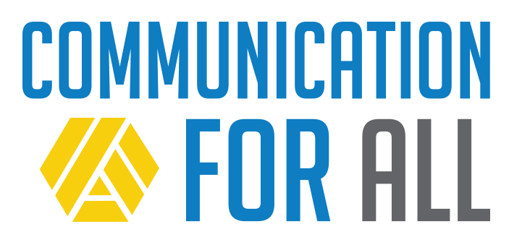
National Call to Action

Effective communication is a fundamental element of life.

It’s essential for:
  - Personal safety, social relationships, and the development of identity and autonomy,
  - Access to and progress in the general curriculum,
  - Access to the community, and
  - Informed participation in a democratic society.

Systems exist to support the development of communication skills for all people with disabilities.

While solutions for individuals vary, early intervention and school programs provide children and adolescents with disabilities access to communication supports and services in early childhood, often beginning at birth and throughout their school career. Adults also benefit from ongoing supports and services needed to learn and to continue communicating. Comprehensive reviews of twenty years of literature document effective strategies and practices that result in improvement in communication status (Snell et al., 2010; Beukelman et al., 2007; Rowland and Schweigert, 2000). This is especially true when communication support begins early and continues into adulthood.

Communication tools including apps on commercial technologies and other forms of augmentative and alternative communication (AAC) are now more accessible, affordable, easy to use, and socially accepted than ever before.

But, too many people with disabilities do not receive the communication support they need to succeed!

Nearly 30% of students who take what is known as the “alternate assessment” in school are not supported to communicate effectively, even when they show the ability and intent to do so. About half of these students communicate for restricted purposes using only basic signs, symbols, and gestures. Even more tragic, is the fact that 9-12% of students taking the alternate assessment leave high school without a consistent means of expressive communication, even though they are attentive to and engage with others.

As adults, too many people with disabilities face challenges accessing comprehensive supports that are required for effective communication.

This all comes at a cost to people with disabilities, their families, and society as a whole!

Most quality of life elements, such as personal safety, choice, relationships, health and well-being, employment, and so much more are severely limited by an inability to communicate.

We can and must prevent this result for people with disabilities and their families!

TASH urges all partners, stakeholders, and advocates to join our
National Call to Action!

On behalf of individuals with complex disabilities we urge our partners, stakeholders, and advocates to promote life-long communication supports through:
- awareness,
- professional development, and
- access to communications technologies, ongoing instruction, and support.

Take Action!

- Starting early is key, however it’s never too late for a person to learn to communicate.
- Support choice because individuals with complex disabilities should have a role in choosing their own modes of communication.
- Assume that everyone wants an effective means of communication.

What can YOU do if you are a…

Advocate:
- Know the facts:
  - There are no prerequisites for using AAC: no minimum age, IQ, skills, or behaviors that have to be met before your family member can learn to use an AAC system.
  - Using AAC does not inhibit a person’s ability to use oral speech at a later time.
  - Communication is not the same as compliance. People with disabilities need options for a broad range of purposes with a range of communication partners.
- Advocate for communication supports to be provided until competency is achieved and sustained.

Education Leader:
- Ensure that all students using AAC have opportunities to communicate.
- Set a good example for valuing communication in all forms.
- Provide opportunities for professional development.
- Allocate resources to support communication supports and services for all students.
- Support effective access to peers and the general education curriculum.

Parent/Caregiver:
- Recognize that behavior is communication. Share what you know about the ways your son/daughter uses behavior to communicate.
- Work with your school team or support services to continue a communication system between home and school and/or work.
- Create opportunities for your son/daughter to communicate.
- Know that there are no prerequisites for using AAC: no minimum age, IQ, skills, or behaviors that have to be met before your family member can learn to use an AAC system.

Policy Maker:
- Understand the essential role that communication plays in human development, learning, employment, safety, health, and all other quality of life outcomes and allocate necessary resources for communication supports and services to be provided.
- Ask questions. Find out if students in your jurisdiction are leaving school without an ability to communicate or if adults in your community do not have access to supports. If yes, work with stakeholders to solve barriers to supports and services.

Researcher:
- Lost opportunities to communicate are rampant in schools and adult life. Identify trends and effective interventions for helping children and adults with disabilities and their families, teachers, and service providers seek out and utilize those opportunities.

Self-Advocate:
- Share your story.
- Help a friends share their story.
- Work with other advocates to create change in schools, workplaces, and the community.

Service Provider:
- Provide support services that ensure people with disabilities can use AAC and communicate effectively at home, school, and/or work.
- Provide communication services until an individual has a reliable, consistent, and effective means of communication, even if they do not seem to be progressing for years at a time.
- Remain current on effective AAC practices.

Teacher:
- Ensure every student has options for communicating at all times.
- Accept all forms of communication and respond.
- Focus on the communicative intent behind student behaviors, even when the behaviors are challenging or aggressive.
- Encourage the use of AAC throughout the school day.
- Remember that communication is not compliance. Students should have opportunities to communicate for a broad range of purposes with a range of communication partners.

It is never too late for a person to learn to communicate.
Take action now!

References

Beukelman, D. R., Fager, S., Ball, L., & Dietz, A. (2007). AAC for adults with acquired neurological conditions: A review. Augmentative and Alternative Communication, 23, 230-242.

Snell, M. E., Brady, N., McLean, L., Ogletree, B. T., Siegel, E., Sylvester, L., ... Sevcik, R. (2010). Twenty years of communication intervention research with individuals who have severe intellectual and developmental disabilities. American Journal on Intellectual and Developmental Disabilities, 115, 364-380.

