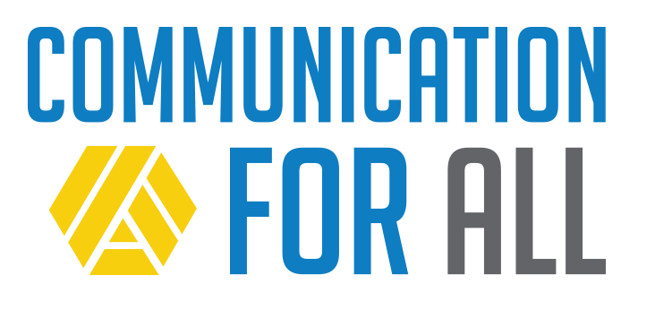
National Call to Action
Communication is a basic part of life.

It’s important for:
    - Relationships, learning about who you are, and personal safety & control
    - Being included in regular classes in school,
    - Being part of the community
    - Being a good citizen.

There are systems that can help all people with disabilities learn to communicate.

Preschool and school programs help children and teenagers with disabilities learn to communicate.

Adults with disabilities can also get help that they need to communicate what it is important to them.
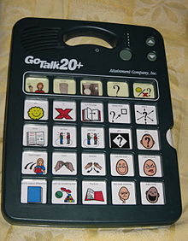
Communication tools include apps on things like IPads and Smartphones. Other forms of augmentative and alternative communication (AAC) are now easier to find and use, affordable, and socially accepted than ever before.

Too many people with disabilities do not get the communication help they need to succeed!

Many students take what is known as the “alternate assessment or test” in school but they do not get the help they need to communicate their answers.

About ten percent of the students who take the alternate test leave high school without way to communicate what they need or want.
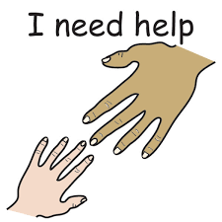

Many adults have a hard time getting they help they need to communicate.

This all comes at a cost to people with disabilities, their families, and society as a whole!

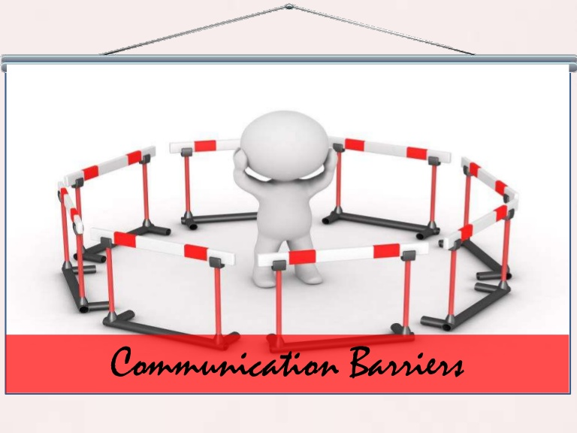
Things that important to having a good life like personal safety, choice, relationships, health and well-being, employment, and so much more are severely limited by an inability to communicate.

We can and must prevent this result for people with disabilities and their families!

TASH wants all of our partners, stakeholders, & advocates to join our
National Call to Action!
We want our partners, stakeholders, and advocates to promote life-long communication supports through: awareness, professional development, and helping people with disabilities get communications technology, ongoing instruction, and support.

Take Action!

- It’s never too late for a person to learn to communicate.
- Individuals with complex disabilities should be able to choose what they will use for communication.
- Assume that everyone wants an effective way to communication.

What can YOU do if you are a…

Advocate:
- Know the facts:
  - There are no prerequisites for using AAC: no minimum age, IQ, skills, or behaviors that have to be met before your family member can learn to use an AAC system.
  - Using AAC does not inhibit a person’s ability to use oral speech at a later time.
  - Communication is not the same as compliance. People with disabilities need options for a broad range of purposes with a range of communication partners.
- Advocate for communication supports to be provided until competency is achieved and sustained.

Education Leader:
- Ensure that all students using AAC have opportunities to communicate.
- Set a good example for valuing communication in all forms.
- Provide opportunities for professional development.
- Allocate resources to support communication supports and services for all students.
- Support effective access to peers and the general education curriculum.

Parent/Caregiver:
- Recognize that behavior is communication. Share what you know about the ways your son/daughter uses behavior to communicate.
- Work with your school team or support services to continue a communication system between home and school and/or work.
- Create opportunities for your son/daughter to communicate.
- Know that there are no prerequisites for using AAC: no minimum age, IQ, skills, or behaviors that have to be met before your family member can learn to use an AAC system.

Policy Maker:
- Understand the essential role that communication plays in human development, learning, employment, safety, health, and all other quality of life outcomes and allocate necessary resources for communication supports and services to be provided.
- Ask questions. Find out if students in your jurisdiction are leaving school without an ability to communicate or if adults in your community do not have access to supports. If yes, work with stakeholders to solve barriers to supports and services.

Researcher:
- Lost opportunities to communicate are rampant in schools and adult life. Identify trends and effective interventions for helping children and adults with disabilities and their families, teachers, and service providers seek out and utilize those opportunities.

Self-Advocate:

- Tell your story
- Help a friend tell their story
- Work with other advocates to make changes to school and adult programs

Service Provider:
- Provide support services that ensure people with disabilities can use AAC and communicate effectively at home, school, and/or work.
- Provide communication services until an individual has a reliable, consistent, and effective means of communication, even if they do not seem to be progressing for years at a time.
- Remain current on effective AAC practices.

Teacher:
- Ensure every student has options for communicating at all times.
- Accept all forms of communication and respond.
- Focus on the communicative intent behind student behaviors, even when the behaviors are challenging or aggressive.
- Encourage the use of AAC throughout the school day.
- Remember that communication is not compliance. Students should have opportunities to communicate for a broad range of purposes with a range of communication partners.

It is never too late for a person to learn to communicate.
Take action now!

References

Beukelman, D. R., Fager, S., Ball, L., & Dietz, A. (2007). AAC for adults with acquired neurological conditions: A review. Augmentative and Alternative Communication, 23, 230-242.

Snell, M. E., Brady, N., McLean, L., Ogletree, B. T., Siegel, E., Sylvester, L., ... Sevcik, R. (2010). Twenty years of communication intervention research with individuals who have severe intellectual and developmental disabilities. American Journal on Intellectual and Developmental Disabilities, 115, 364-380.

